**FDD deep demersal** fish Ruby fish, deepwater flathead, Warty oreo, Mirror dory, Pink ling, Ribaldo, Gemfish, *Deania calcea*

**Ruby fish *Plagiogeneion rubiginosum*** no info

**Deepwater Flathead Platycephalus conatus** Primarily piscivorous, also large benthic crustaceans

*Lepidorhombus boscii* in the oligotrophic Aegean Sea Decapod natants, namely *Processa* *canaliculata* and *Alpheus glaber*, dominated in terms of per cent mass, while mysids, represented mainly by *Lophogaster typicus*, were the most important dietary component in terms of per cent number. Isopods, amphipods and decapod brachyurans were also frequently encountered among stomach contents. Fishes were only ingested by larger specimens (>180 mm total length, LT). The diet of the four-spotted megrim in the Aegean consisted predominantly of crustaceans. The N% made up 92.43% of the stomach contents (Table III).

Mysids (37_3%) were the most important in terms of numerical abundance (mainly *Lophogaster typicus*) followed by decapod natants (23.5%), with *Processa canaliculata* and *Alpheus glaber* making a relatively high contribution to the total number of prey ingested by the species. Brachyurans (*Goneplax rhomboids* and *Monodaeus* sp.), anomurans (*Munida* sp.), isopods (*Cirolana borealis*) and amphipods (*Ampelisca diadema* and *Hyale shmidti*) were encountered relatively frequently in stomach contents. Large prey were swallowed intact. Cannibalistic predation of four specimens (LT > 180 mm) on young-of-the-year

(YOY) (LT < 40 mm) occurred; each of the stomachs of the four cannibals contained only one juvenile. In all cases when fish or large decapods were ingested, only one such prey was found in the stomach. In terms of M%, crustaceans (75%) dominated among stomach contents with natants contributing 37.4%, anomurans 9.2% and reptants 8.4% (Table III).

Mysids, although making a rather substantial numerical contribution to the overall diet of the species, contributed only 10% by mass. The opposite occurred in teleosts, which constituted an important dietary component by mass (21.1%), while their numerical contribution was rather limited. Isopods and molluscs contributed 4.2 and 3.4%, respectively, by mass, while amphipods, polychaetes and copepods were only of minor importance. The five prey species found most often in the stomachs were *Processa canaliculata, Lophogaster typicus, Alpheus glaber, Cirolana borealis* and *Munida* sp. Among the major prey categories present in the diet of the fourspotted megrim, natants were found in 24.6% and mysids in 24% of the stomachs analysed. The F% of isopods and teleosts in the stomachs were 6.8 and 6%, respectively, while the rest of the prey categories exhibited limited occurred in limited numbers.

Warty oreo *(Allocyttus verrucosus)* Crustaceans in 71% fish, fish in 33%, and cephalopods in 26%.. Crustaceans: cariid prawns, gammarid amphipods and copepods, fish: Myctophidae, Macrouridae, Neoscopolidae, Gonostomatidae, and Nemichthyidae. Cephalopods: squid.

**Mirror dory** (*Zenopsis nebulosus*) The food consists mostly of macroplanktonic fish, crustaceans and squid

Title: [**Ecological characteristics of the mirror dory Zenopsis nebulosis[sic] from the Naska Ridge.**](http://apps.webofknowledge.com/full_record.do?product=UA&search_mode=GeneralSearch&qid=58&SID=Q2hKRo9syiZkLeQAy2t&page=1&doc=4)

Author(s): Parin, N.V.; Pavlov, Yu.P.; Andrianov, D.P.

Source: Voprosy Ikhtiologii  Volume: **28**   Issue: **5**   Pages: **707-716**   Published: **1988**

**Pink Ling** *Genypterus blacodes*

The diet of ling was diverse, but characterised by benthic crustaceans and demersal fishes (Appendix S1). Galatheids (mainly Munida gracilis) occurred in 50% of stomachs but were relatively small and so contributed only 7% of prey weight. *Metanephrops challengeri* were a relatively large crustacean prey, and contributed a similar weight to galatheids despite occurring in only 9% of stomachs. The fish prey included benthic species, such as eels and

flatfish, demersal species such as hoki, mesopelagic species such as myctophids, and 3 instances of cannibalism, but the most important fish prey by %IRI were demersal macrourids, which were found in 17% of stomachs, contributed 16% of prey weight, and consisted of at least 7 species. The greatest %W was from discarded fish remains (30%), which were predominantly severed heads and/or tails of the pelagic jack mackerel Trachurus spp., or heads of other fishes with no other accompanying remains, e.g., one stomach contained only 4 hoki heads. By prey weight, Galatheidae, Pandalidae, and Goneplacidae were most important in the diet at depths of 255–381 m; Galatheidae and Nephropidae were most important at depths of 382–428 m; Galatheidae, Nephropidae, Macrouridae,

Mysidae, and discarded fishes were most important at depths of 429–791 m, with fish prey dominant (mean %W.50%) at 562–791 m. The MDS plot for fish length indicated similar diets at 32.7–58.8 cm, 58.9–82.9 cm, 83.0–103.6 cm, and 103.8–149.7 cm (Fig. 5). By prey weight, Galatheidae and Pandalidae were most important in the diet of smaller ling of 32.7–58.8 cm; Galatheidae, Pandalidae, Goneplacidae, and Macrouridae were most important

in intermediate sized ling of 58.9–82.9 cm; Galatheidae, Nephropidae, Macrouridae, and discarded fish were most important in the larger ling of 83.0–149.7 cm, with Anguilliformes also important at 103.8–149.7 cm.

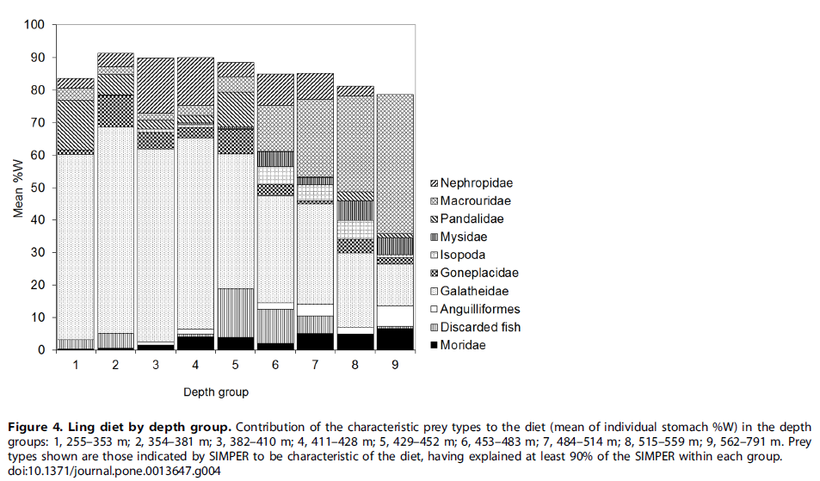

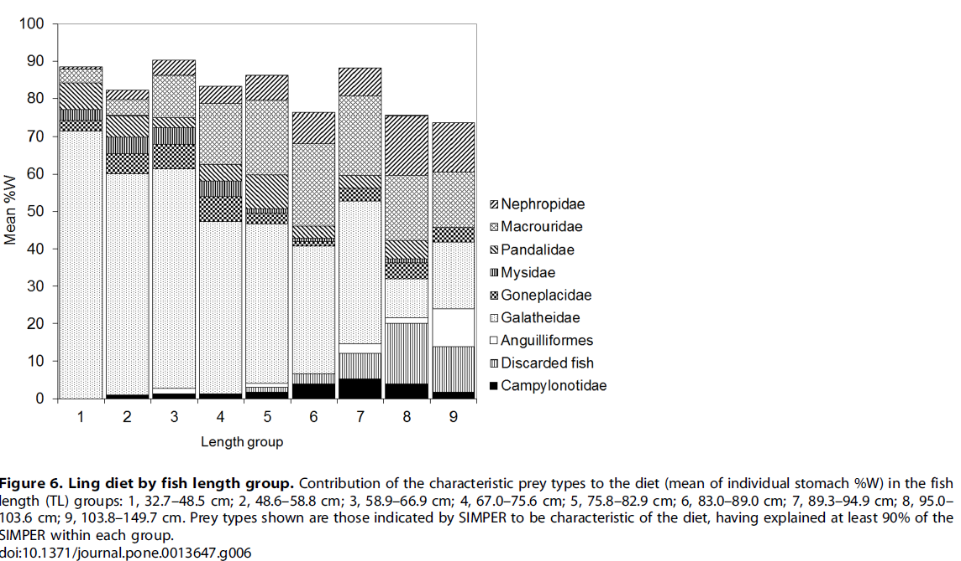Ling was a benthic generalist, with a wide range of potential prey, including scavenging; the broad diet makes ling a potential keystone species. Scavenging was most pronounced in intermediate sized ling.

Piscivorous. The macrourid Lepidorhynchus denticulatus is the most important prey of G. blacodes. Genypterus blacodes has a catholic diet of fishes and larger crustaceans, carid shrimps.

Title: [**Diet of Two Large Sympatric Teleosts, the Ling (Genypterus blacodes) and Hake (Merluccius australis)**](http://apps.webofknowledge.com/full_record.do?product=UA&search_mode=GeneralSearch&qid=59&SID=Q2hKRo9syiZkLeQAy2t&page=1&doc=10)

Author(s): Dunn, Matthew R.; Connell, Amelia M.; Forman, Jeff; et al.

Source: PLOS ONE  Volume: **5**   Issue: **10**     Article Number: **e13647**   DOI: **10.1371/journal.pone.0013647**   Published: **OCT 27 2010**

[**FEEDING OF LING GENYPTERUS-BLACODES (BLOCH AND SCHNEIDER) FROM 4 NEW-ZEALAND OFFSHORE FISHING GROUNDS**](http://apps.webofknowledge.com/full_record.do?product=UA&search_mode=GeneralSearch&qid=59&SID=Q2hKRo9syiZkLeQAy2t&page=10&doc=91)

Author(s): MITCHELL, SJ

Source: NEW ZEALAND JOURNAL OF MARINE AND FRESHWATER RESEARCH  Volume: **18**   Issue: **3**   Pages: **265-274**   Published: **1984**

[**Variation in the diet of Genypterus blacodes (Ophidiidae) around the Falkland Islands**](http://apps.webofknowledge.com/full_record.do?product=UA&search_mode=GeneralSearch&qid=59&SID=Q2hKRo9syiZkLeQAy2t&page=4&doc=36)

Author(s): Nyegaard, M; Arkhipkin, A; Brickle, P

Source: JOURNAL OF FISH BIOLOGY  Volume: **65**   Issue: **3**   Pages: **666-682**   DOI: **10.1111/j.1095-8649.2004.00476.x**

Title: [**DIETS OF FISHES OF THE UPPER CONTINENTAL-SLOPE OF EASTERN TASMANIA - CONTENT, CALORIFIC VALUES, DIETARY OVERLAP AND TROPHIC RELATIONSHIPS**](http://apps.webofknowledge.com/full_record.do?product=UA&search_mode=GeneralSearch&qid=59&SID=Q2hKRo9syiZkLeQAy2t&page=8&doc=80)

Author(s): BLABER, SJM; BULMAN, CM

Source: MARINE BIOLOGY  Volume: **95**   Issue: **3**   Pages: **345-356**   DOI: **10.1007/BF00409564**   Published: **1987**

[**Food habits of some deep-sea fish off South Africa's west coast. 2. Eels and spiny eels (Anguilliformes and Notacanthiformes)**](http://apps.webofknowledge.com/full_record.do?product=UA&search_mode=GeneralSearch&qid=56&SID=Q2hKRo9syiZkLeQAy2t&page=5&doc=42)

Author(s): Anderson, ME

Source: AFRICAN JOURNAL OF MARINE SCIENCE  Volume: **27**   Issue: **3**   Pages: **557-566**   DOI: **10.2989/18142320509504116**   Published: **DEC 2005**

[**Food habits of some deep-sea fish off South Africa's west coast and Agulhas Bank. 1. The grenadiers (Teleostei : Macrouridae)**](http://apps.webofknowledge.com/full_record.do?product=UA&search_mode=GeneralSearch&qid=56&SID=Q2hKRo9syiZkLeQAy2t&page=5&doc=43)

Author(s): Anderson, ME

Source: AFRICAN JOURNAL OF MARINE SCIENCE  Volume: **27**   Issue: **2**   Pages: **409-425**   DOI: **10.2989/18142320509504100**

Ribaldo *Mora moro* no info

**Gemfish** Rexea solandri no info

# The slickheads (Alepocephalidae)

*Alepocephalus australis* Pelagic tunicates, particularly the pyrosome *Pyrosoma atlanticum* Péron, 1804,were the most important food item with natant decapods prawns and squid less so (Table1). Calanoid copepods, pelagic tunicates (pyrosomes and salp remains),and the remains of fish were the most abundant food items recovered from the intestines. Calanoid copepod remains were recovered from the intestines, but not from stomachs, while squid remains were recovered from the stomachs, but not the intestines.

A. antipodianus Fish were the most important food item recovered from stomachs, followed by pelagic tunicates and natant decapod prawns. The remains of fish and pelagic tunicates were the most frequently occurring material recovered from the intestines.Ostracods and calanoid copepods were recovered from the intestines but not from the stomachs.

Xenodermichthys copei: The stomach contents of X. copei comprised primarily natant decapods prawns,calanoid copepods, fish remains,and gammarid, and hyperiid amphipods Thei ntestinal contents of X. copei were mainly madeup of natant decapods,gammarid and hyperiid amphipods, and calanoid copepods.

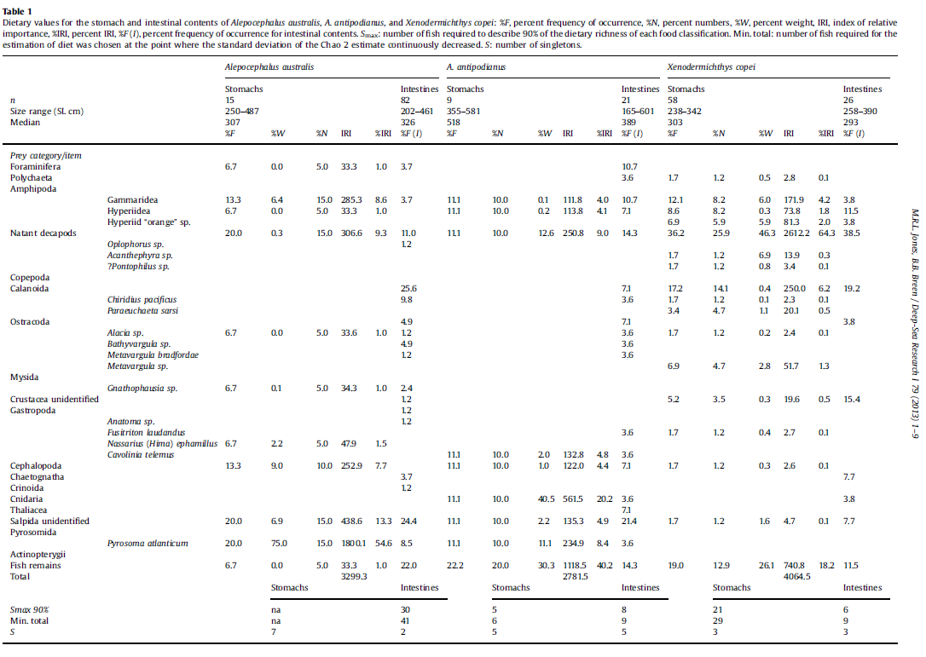

**southern lanternshark** (Etmopterus baxteri) In broad terms, the diet of E. baxteri was dominated by teleosts, which were found in .67% of all specimens with food and contributed _80% by weight to the diet. Cephalopod prey were also important and found in 41% of the stomachs with food, although the %IRI value for cephalopods was just 18.1% owing to their relatively small contribution by weight (16.72%). Crustaceans were a minor component, found in 7.5% of the stomachs with food, and represented just 1.7% of all prey items by weight, with a %IRI of 0.5%. Vampire squid (Vampyroteuthis infernalis) were found in .12% of all stomachs with food, yet a low %W value of 2% resulted in that species having an IRI value of just 5.6%. Unidentified teleost and cephalopod prey had IRI values of 36.0 and 8.9%, respectively, but the most important prey item was orange roughy (42.4%IRI), primarily because of the large contribution of this species in terms of wet weight. Benthic teleosts and benthic cephalopods dominated the identifiable diet with a combined IRI of 66.8%, although pelagic prey formed one-third of the diet of E. baxteri. Teleosts were the most important of the pelagic prey types, with an IRI value of 26.7%, whereas pelagic crustaceans, pelagic cephalopods, and tunicates accounted for small proportions of total prey numbers and weights. The diet of E. baxteri appeared to vary by size of predator. The importance of teleost prey increased with length, from 56.5%IRI in the diet of fish 290–549 mm LT to ca. 86%IRI for fish in the 750–900-mm length class, whereas crustaceans were apparently important (25%IRI) only in the diet of the few fish sampled in the 290–549-mm length class. The contribution of cephalopod prey was variable across length classes, ranging from 13.7 to 21.2%IRI, and the contribution of other prey was minor (≤0.5%IRI) across all length classes. In several respects, the diet of E. baxteri is similar to that of orange roughy. Pelagic teleosts accounted for 27%W of the identifiable diet of E. baxteri, comparable with the 23%W. The pelagic teleost prey taken by E. baxteri included Epigonus lenimen, Chauliodus sp., and myctophids, each of which has also been reported from the diet of orange roughy (Bulman and Koslow, 1992). Benthic cephalopods, notably Histioteuthis miranda and Vampyroteuthis infernalis, were found in almost one-third of E. baxteri stomachs with identifiable food, but made only a minor contribution by weight. Cephalopod prey in the stomachs of orange roughy from eastern Tasmania constituted 23%W and 11.1%O (Bulman and Koslow, 1992). The diet of E. baxteri is indicative of a bentho-pelagic piscivore. Similarly, orange roughy are opportunistic predators of bentho- and mesopelagic crustaceans, fish, and squid (Bulman and Koslow, 1992). The occurrence of shared prey species in the diets of E. baxteri and orange roughy, and a suggestion of similar size-related variation in their diets, indicates the potential for competition between the two species.

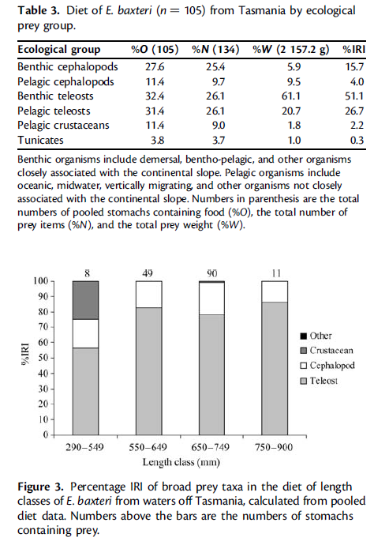

**Etmopterus unicolour** The diet of E. unicolor differed from that of E. baxteri in broad terms and was dominated by cephalopods (84.5%IRI), which were found in 89% of the stomachs with food (Table 4). Identified teleost, crustacean, and pyrosome prey each had an IRI value of ,1%. An unexpected inclusion in the diet was that of penguin tissue (family Spheniscidae). Histioteuthid squid were important in the diet of E. unicolor, with a combined IRI value of 44.2%, most of which was attributable to the prevalence of Histioteuthis macrohista and unidentified histioteuthid tissues. An unidentified cranchiid squid species was also prominent in the diet, found in .14% of the fish containing identifiable food items. The identifiable diet of E. unicolor was composed almost totally of benthic cephalopods (96.03%IRI; Table 5), although that value has been inflated by the elimination of unidentified teleost prey, which accounted for a relatively large proportion of the total diet (Table 4), from the analysis. Benthic cephalopods were found in almost three-quarters of all stomachs containing identifiable food items and accounted for .75% of total identifiable prey numbers. Although infrequent (5.3%O), pelagic cephalopods. accounted for almost 30% of the total identifiable prey weight, attributable to the presence of a few large individuals. The importance of teleost prey appeared to increase with shark length, whereas crustaceans were important in the diet of the few individuals ,550 mm LT and absent from that of fish ≥750 mm LT.

Identifiable prey taxa in the diet of E. unicolor consisted almost totally of benthic cephalopods, with the inclusion of several species of small pelagic teleost. In the only other study to consider the diet of E. unicolor off southeastern Australia, small, unidentified squid

were found in 80% of the stomachs with food, along with three bathypelagic fish species (Daley et al., 2002). Histioteuthid squid, notably Histioteuthis macrohista, were common in the diet of E. unicolor, with a large contribution by weight. The geographic distribution of H. macrohista and several other histioteuthids, including H. atlantica, is closely related to the intrusion of Antarctic Intermediate Water (AAIW) onto continental slopes (Roeleveld et al., 1992), and it is likely that residual northward currents at mid-slope depths (800–1200 m) around Tasmania brought these benthic cephalopod species in proximity to Etmopterus spp. on the mid-slope (Koslow et al., 1994). Several pieces of penguin flesh (family Spheniscidae) were also retrieved from the stomach of an individual E. unicolor caught on the Southern Hills off Tasmania. Penguins have not previously been recorded as the prey of Etmopterus spp., and this incidence indicates that the largely teuthivorous E. unicolor is an opportunistic

scavenger of falling carcasses.

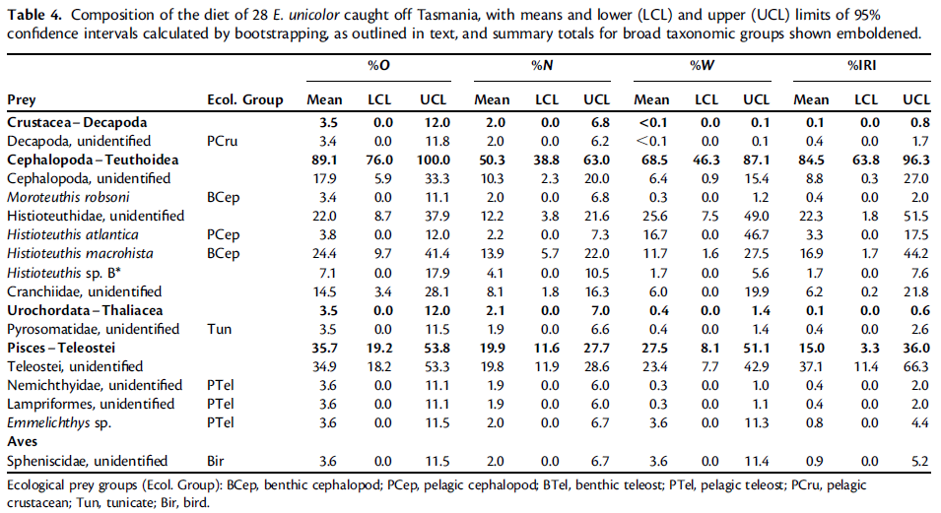

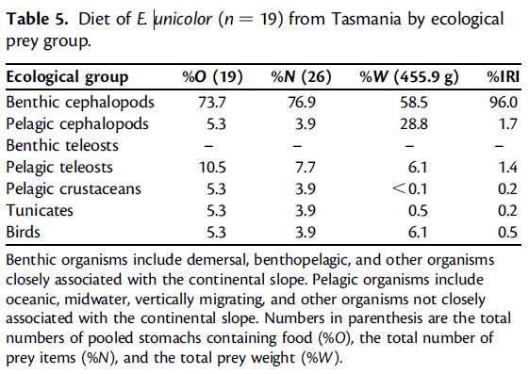

Deepwater Flathead

|  |  |
| --- | --- |
| **prey item** | **probability of consuming** |
| ZKL | 0.3 |
| FDD | 0.05 |
| ORR | 0.05 |
| MAZ | 0.1 |
| ZME | 0.1 |
| BG | 0.1 |
| FMP | 0.2 |
| CEP | 0.1 |
| PRW | 0.2 |

>180 mm

|  |  |
| --- | --- |
| **prey item** | **probability of consuming** |
| ZKL | 0.3 |
| FDD | 0.2 |
| ORR | 0.2 |
| MAZ | 0.1 |
| ZME | 0.05 |
| BG | 0.05 |
| FMP | 0.3 |
| CEP | 0.3 |
| PRW | 0.2 |

Pink Ling

32.7-48.5 cm

|  |  |
| --- | --- |
| **prey item** | **probability of consuming** |
| MAZ | 0.3 |
| PRW | 0.1 |
| FDD | 0.05 |

48.6-58.8 cm

|  |  |
| --- | --- |
| **prey item** | **probability of consuming** |
| MAZ | 0.3 |
| PRW | 0.1 |
| FDD | 0.05 |

58.9-66.9 cm

|  |  |
| --- | --- |
| **prey item** | **probability of consuming** |
| MAZ | 0.3 |
| PRW | 0.1 |
| FDD | 0.1 |

67-75.6 cm

|  |  |
| --- | --- |
| **prey item** | **probability of consuming** |
| MAZ | 0.3 |
| PRW | 0.1 |
| FDD | 0.15 |

75.8-82.9 cm

|  |  |
| --- | --- |
| **prey item** | **probability of consuming** |
| MAZ | 0.25 |
| PRW | 0.1 |
| FDD | 0.2 |

83-89 cm

|  |  |
| --- | --- |
| **prey item** | **probability of consuming** |
| MAZ | 0.25 |
| PRW | 0.1 |
| FDD | 0.2 |

89.3-94.9 cm

|  |  |
| --- | --- |
| **prey item** | **probability of consuming** |
| MAZ | 0.25 |
| PRW | 0.1 |
| FDD | 0.2 |

95-103.6 cm

|  |  |
| --- | --- |
| **prey item** | **probability of consuming** |
| MAZ | 0.2 |
| PRW | 0.1 |
| FDD | 0.28 |

103.8-149.7 cm

|  |  |
| --- | --- |
| **prey item** | **probability of consuming** |
| MAZ | 0.2 |
| PRW | 0.1 |
| FDD | 0.3 |

The slickheads

|  |  |
| --- | --- |
| **prey item** | **probability of consuming** |
| SAL | 0.3 |
| ZKL | 0.1 |
| CEP | 0.1 |
| ZME | 0.1 |

southern lanternshark

290-549 mm

|  |  |
| --- | --- |
| **prey item** | **probability of consuming** |
| MAZ | 0.1 |
| PRW | 0.1 |
| CEP | 0.2 |
| ORR | 0.2 |
| FDD | 0.2 |
| FMP | 0.2 |
| SAL | 0.2 |

550-649 mm

|  |  |
| --- | --- |
| **prey item** | **probability of consuming** |
| CEP | 0.2 |
| ORR | 0.3 |
| FDD | 0.3 |
| FMP | 0.3 |
| SAL | 0.3 |
| CEP | 0.3 |

650-749 mm

|  |  |
| --- | --- |
| **prey item** | **probability of consuming** |
| CEP | 0.2 |
| ORR | 0.3 |
| FDD | 0.3 |
| FMP | 0.3 |
| SAL | 0.3 |
| CEP | 0.3 |

750-900 mm

|  |  |
| --- | --- |
| **prey item** | **probability of consuming** |
| CEP | 0.2 |
| ORR | 0.3 |
| FDD | 0.3 |
| FMP | 0.3 |
| SAL | 0.3 |
| CEP | 0.3 |

Etmopterus unicolour - southern lanternshark

550 mm

|  |  |
| --- | --- |
| **prey item** | **probability of consuming** |
| CEP | 0.3 |
| MAZ | 0.2 |
| FDD | 0.3 |
| FMP | 0.3 |
| SAL | 0.1 |
| CEP | 0.3 |
| ORR | 0.1 |

>750 mm

|  |  |
| --- | --- |
| **prey item** | **probability of consuming** |
| CEP | 0.3 |
| ORR | 0.1 |
| FDD | 0.3 |
| FMP | 0.3 |
| SAL | 0.3 |
| CEP | 0.3 |

**Summary of all FDDs**

slickheads 1

|  |  |
| --- | --- |
| **prey item** | **probability of consuming** |
| SAL | 0.3 |
| ZKL | 0.1 |
| CEP | 0.1 |
| ZME | 0.1 |

Deepwater Flathead small 2

|  |  |
| --- | --- |
| **prey item** | **probability of consuming** |
| ZKL | 0.3 |
| FDD | 0.05 |
| ORR | 0.05 |
| MAZ | 0.1 |
| ZME | 0.1 |
| BG | 0.1 |
| FMP | 0.2 |
| CEP | 0.1 |
| PRW | 0.2 |

Flathead >180 mm 3

|  |  |
| --- | --- |
| **prey item** | **probability of consuming** |
| ZKL | 0.3 |
| FDD | 0.2 |
| ORR | 0.2 |
| MAZ | 0.1 |
| ZME | 0.05 |
| BG | 0.05 |
| FMP | 0.3 |
| CEP | 0.3 |
| PRW | 0.2 |

Pink Ling 103.8-149.7 cm 4

|  |  |
| --- | --- |
| **prey item** | **probability of consuming** |
| MAZ | 0.2 |
| PRW | 0.1 |
| FDD | 0.3 |

southern lanternshark 290-549 mm Pink Ling 327-588 mm 5

|  |  |
| --- | --- |
| **prey item** | **probability of consuming** |
| MAZ | 0.1 0.2 0.3 |
| PRW | 0.1 0.1 0.1 |
| CEP | 0.2 0.25 |
| ORR | 0.2 0.15 |
| FDD | 0.2 0.25 0.05 |
| FMP | 0.2 0.25 |
| SAL | 0.2 0.15 |

southern lanternshark 550-649 mm Pink Ling 589-669 mm 6

|  |  |
| --- | --- |
| **prey item** | **probability of consuming** |
| CEP | 0.2 |
| ORR | 0.3 |
| FDD | 0.3 0.1 |
| FMP | 0.3 |
| SAL | 0.3 |
| CEP | 0.3 |
| MAZ | 0.3 |
| PRW | 0.1 |

southern lanternshark 650-749 mm Pink Ling 670-756 mm 7

|  |  |
| --- | --- |
| **prey item** | **probability of consuming** |
| CEP | 0.2 |
| ORR | 0.3 |
| FDD | 0.3 015 |
| FMP | 0.3 |
| SAL | 0.3 |
| CEP | 0.3 |
| MAZ | 0.3 |
| PRW | 0.1 |

southern lanternshark 750-900 mm Pink Ling 750-890 mm 8-10

|  |  |
| --- | --- |
| **prey item** | **probability of consuming** |
| CEP | 0.2 0.3 |
| ORR | 0.3 0.1 |
| FDD | 0.3 0.3 0.2 |
| FMP | 0.3 0.3 |
| SAL | 0.3 0.3 |
| CEP | 0.3 0.3 |
| MAZ | 0.25 |
| PRW | 0.1 |

Reference

J. M. Lyle and D. C. Smith 1997. Abundance and biology of warty oreo *(Allocyttus verrucosus)* and spiky oreo *(Neocyttus rhomboidalis)* (Oreosomatidae) off south-eastern Australia. *Marine and Freshwater Research* 48(2) 91 - 102

M.R.L. Jones n, B.B.Breen 2013 Food and feeding relationships of three sympatric slickhead species (Pisces: Alepocephalidae) from northeastern Chatham Rise, New Zealand Deep-Sea ResearchI79(2013)1–9

Hallett, C. S., and Daley, R. K. 2011. Feeding ecology of the southern lanternshark (*Etmopterus baxteri*) and the brown lanternshark (*E. unicolor*) off southeastern Australia. – ICES Journal of Marine Science, doi:10.1093/icesjms/fsq143.

V. Vassilopoulou. 2006. Dietary habits of the deep-sea flatfish *Lepidorhombus*

*boscii* in north-eastern Mediterranean waters. Journal of Fish Biology (2006) 69, 1202–1220

doi:10.1111/j.1095-8649.2006.01199.x,

Blaber SJM, Bulman CM (1987) Diets of fishes of the upper continental slope of eastern Tasmania: content, calorific values, dietary overlap and trophic relationships. Mar Biol 95: 345–356.